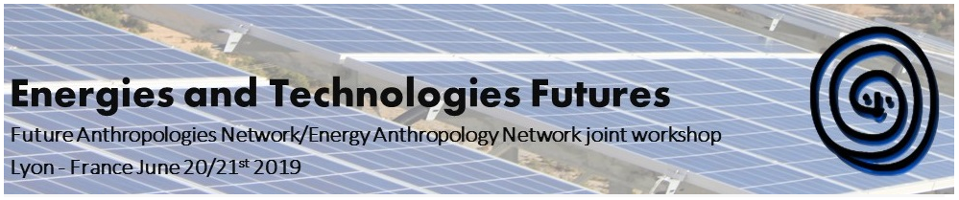
EASA EAN/FAN joint workshop
June 20/21st 2019
ISH, Salle Élise Rivet (4th floor)
14 avenue Berthelot, 69007 Lyon, France

Workshop programme (29/05/19)
9.30 Introduction
10.00 - 12.00 panel one
Sarah Pink - Emerging Technologies Lab, Monash University
Energy Futures and Emerging Technologies: A Design Anthropological Approach
Alexander R.E. Taylor - Department of Social Anthropology/University of Cambridge
Future-proof Clouds: Electromagnetic Pulse Protection in the Data Centre Industry
Julia Velkova - Consumer Society Research Centre/University of Helsinki
Replacing fossil fuels with data: emergent cultures and infrastructural politics around data centres' thermal waste across Europe
Agnese Cimdina - Faculty of Business, Management and Economics University of Latvia
Is technology the answer to the double bind?
12.00 - 13.00 lunch

13.00 - 15.00 panel two
Katherine Ellsworth-Krebs - University of Saint Andrews
Energy demanding expectations: house size, privacy and domestic energy research
Michiel Köhne & Elisabet Rasch - Sociology of Development and Change/Wageningen University
The future of energy in your rented home – Tenants and the energy transition
Charlotte Johnson - UCL Energy Institute, UCL
Is Demand Side Response a woman's work? Domestic labour and the UK's future smart electricity system
15.00 - 18.00 site visit of Lyon Confluences

20.00 – dinner at Restaurant le Musée

Day two
09.00 - 11.30 panel three
Chiara Bresciani - The Cairns Institute, James Cook University & School of Culture and Society, Aarhus University
Under a rising sun? Solar energy, bright prospects and missed futures
Hsin-yi Lu - Department of Anthropology, National Taiwan University
Wind Futures: Contested Sociotechnical Imaginaries of Renewable Energy in Taiwan
Martín Fonck - Rachel Carson Center for Environment and Society/Ludwig-Maximilians-Universität München
“Explorando el interior de la Cordillera de Los Andes”: an ethnographic approach to the construction of geothermal energy futures in the Chilean Andes Mountains.
Ragnhild Freng Dale -
Between power lines and petroleum: energy futures, art interventions and coloniality in the Norwegian north
11.30 - 11.45 coffee break

11.45 – 13.00 Discussion on publication possibilities and panel proposals for EASA 2020

13.00 - lunch and departure

Attendance is free but please register: https://etechfutures.sciencesconf.org/

